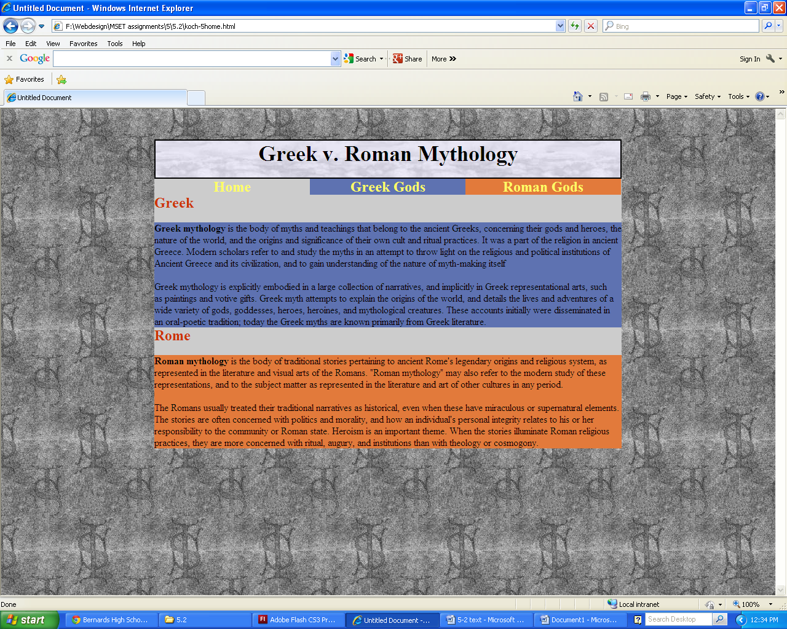

This is just like the notes from 5.1, but we have three divs instead of 2

**11 divs total**

1 wrapper

2 body div (for navigation bar and one for the text)

8 text div

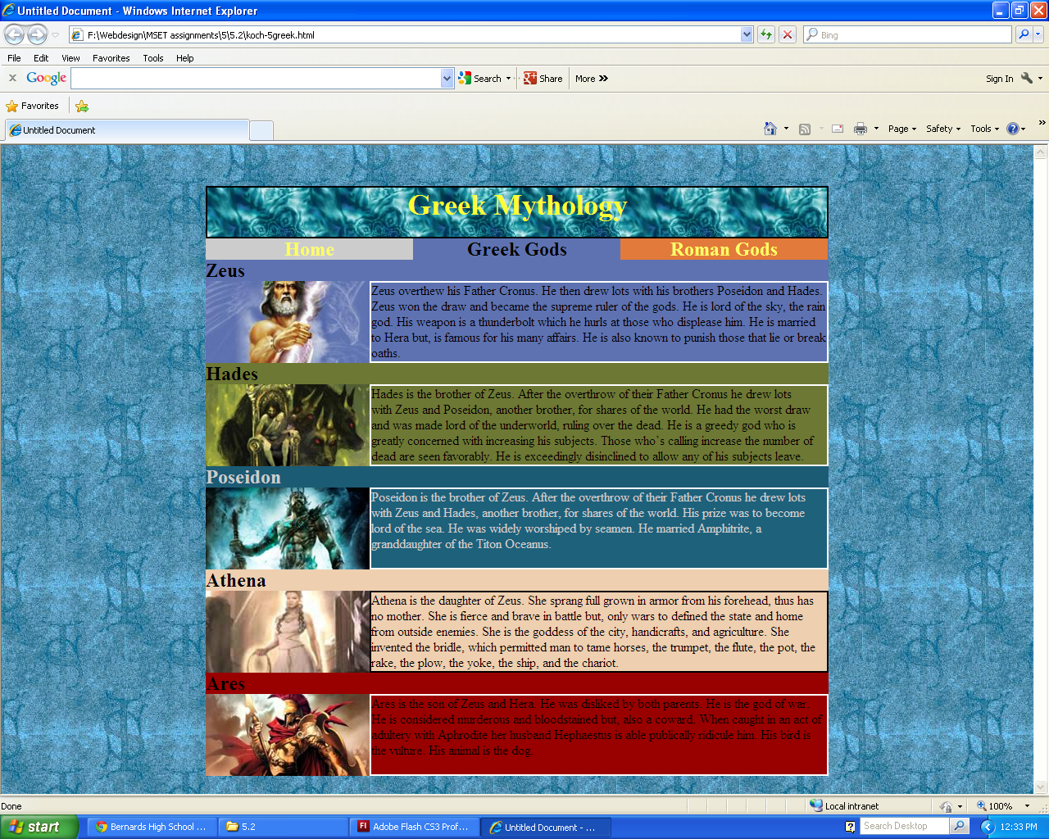This is a series of divs from 5.1. Nothing is new except we are stacking them on top of each other, and the body (the wrapper like div) are reset after each footer (or the next God’s section.)

**22 total divs**

1 wrapper

2 “mainbody” divs (1 to hold the links, 1 to hold the stacked pictures/text)

14 text divs (3 of them are the buttons on top)

5 picture divs

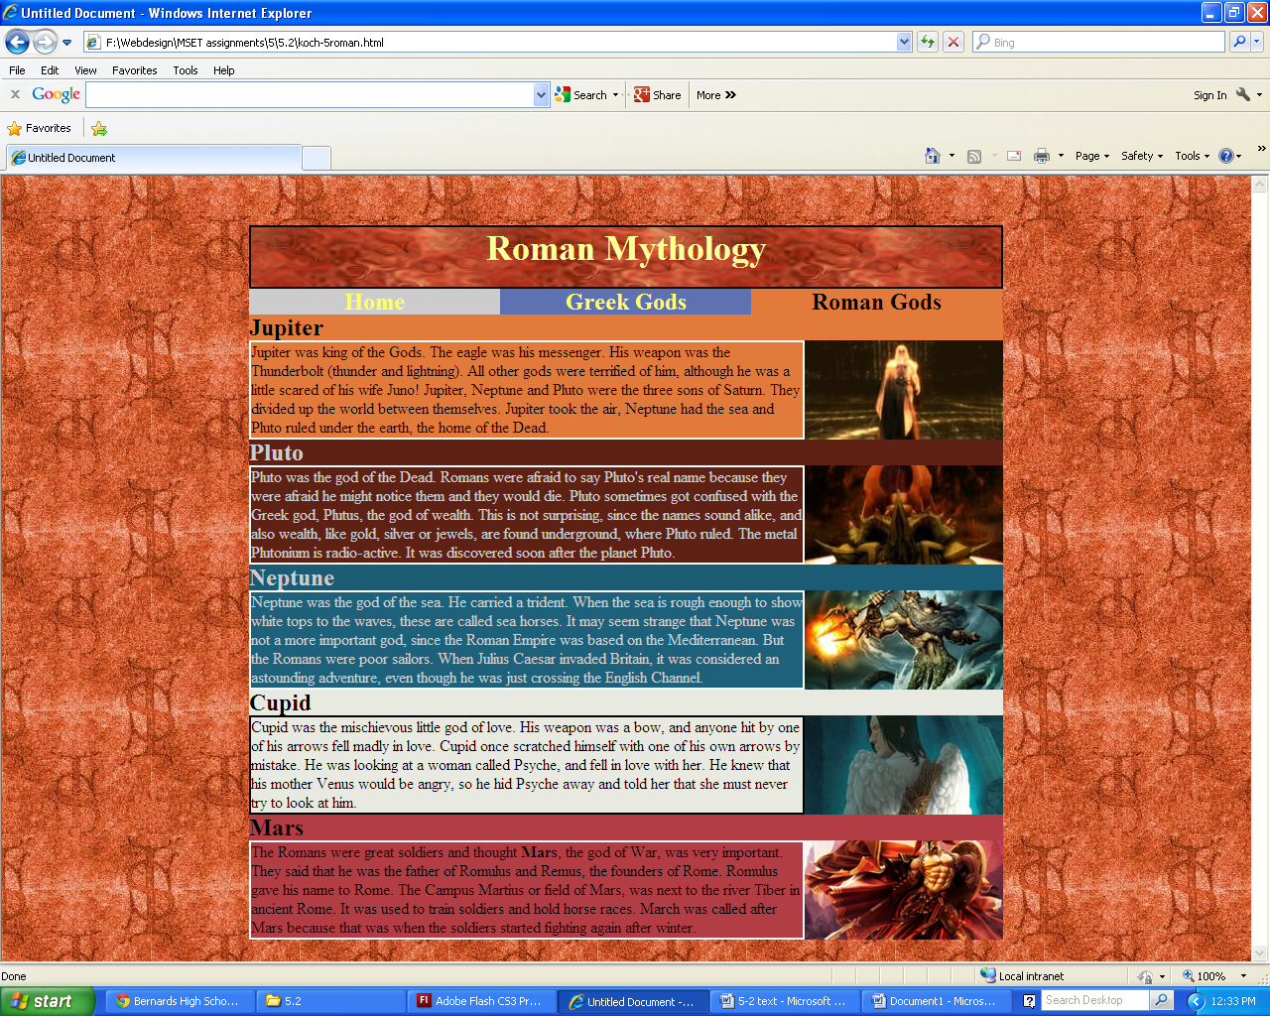

This is just like the notes from 5.1, only right float, and the footer is the next heading

**22 total divs**

1 wrapper

2 “mainbody” divs (1 to hold the links, 1 to hold the stacked pictures/text)

14 text divs (3 of them are the buttons on top)

5 picture divs